
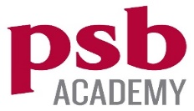

Bachelor of Science with Honours in Computing Science

COURSEWORK No. __1__

Module Name : Communication and Collaboration
Module Code : PSB503IT
Weighting : 10 credits
Due Date : 15/04/2023

Submitted By

Name : Oakar
CU Index No. : 494L4NDO
Word Count : 2150

Declaration Statement
I declare that all the information provided in this portfolio is in accordance with my knowledge and experience. I take full responsibility for the truthfulness of the said information.
Oakar

Profile
My name is Oakar and I am now currently studying in Bachelor in Computing science in Coventry University which the course is supported by PSB academy. I am interested in computer and coding since the age of 12 and passionate about it. There is so many fields in computer science and I am specially intrigued in the field of data science. I love number since I was young and I trust the meaning behind the numbers instead of the words. During my diploma, I studied myself some wed development and basic html and css. I hope I can make a living out of this career and enjoy my life.

Contents
Declaration Statement 2
Profile 2
Introduction 3\
Professional CV___________________________________________________________4
Academic CV_____________________________________________________________6
Tailored CV______________________________________________________________11
My Skillset_______________________________________________________________15
Soft Skills 16
Hard Skills 17
Career Planning for 5 years__________________________________________________18
Conclusion______________________________________________________________20

References_____________________________________________________21

Introduction
This presentation here will include all the skills and experiences that I have since the age of 12. I also develop both interpersonal skill, soft skill and hard skill which will affect the career. I am also eager to learn new skills. In this work, I will represent Professional CV, Academic CV and tailored CV. Moreover, I will highlight the skillset I possess and how they are benefited for my current form and future workplace. Furthermore, the career plan for after one year, 3 years and 5 years will be provided. They will describe how I hope I see myself in future.

Professional CV

Oakar  A passionate student in coding and creating websites for certain solutions.  Profile  A student who is full of eager to learn, currently in computer science, who wants to dip the toe in data scientist field. Have a decent understanding of agile, and SDLC development and have experience in front-end web development projects.  Personal Details  Languages |  | Skills  Education  Bachelor of Science with Honors in Computing Science  March 2023 – Present  Coventry University, Singapore, PSB academy  Ncc lvl 5 Diploma In Computing  September 2019 –September 2020  MCC Institute, Yangon  Ncc lvl 4 Diploma in Computing  September 2018 – September 2019  MCC Institute, Yangon  Projects  Online shopping for Custom built PC, individual PC part and PC component  Create a full-stack website for customers to order items which is available in the store using PHP, and MYSQL (html and CSS) included.  Recipe App using React which is JavaScript framework  Developed a recipe searching app using free API, use React: using useState and useEffect, html and css for design.
  Phone:
  +65 81922709
  Email:
  rhythmic34u@gmail.com
  Address:
  No.666, yishun street 51, blk 502A, 03-499
  Burmese | Native
  English | Fluent
  Chinese | Fluent
  - Web Development(especially front-end)
  - Programming (Python, Javascript, React, C#,PHP, MYSQL)
  - Algorithm and Data Structure
  - Have strong understanding of dynamic programming

Academic CV

OK |  | Oakar  Student | Bachelor in Computing science  Rhythmic34u@gmail.com +65 81922709
Objective |  | Education
A passionate student who is currently studying computer science and has a lot of interest in data science field. I have some experiences in front-end web development projects which support my soft skills and hard skills simultaneously. |  | Bachelor of Science with Honors in Computing Science  March 2023 – Present  Coventry University, Singapore, PSB academy  Ncc lvl 5 Diploma In Computing  September 2019 –September 2020  Modules:  Computing Project  Database design and development  Dynamic website  Information systems analysis  Network security and cryptography  Professional issue in IT  MCC Institute, Yangon  Ncc lvl 4 Diploma in Computing  September 2018 – September 2019  Modules:  Computer Networks  Computer Systems  Database  Designing and Developing object-oriented Computer Programs  Designing and developing a website  Office Solution Development  Skills for Computing  Software Development Techniques  Practicing high school Yangon Institute Of Education  June 2007 – March 2018
Skills |  | Languages
Hard skills  -Web development  -Database and MYSQL  -Multiple programming language and framework (Python, JavaScript, C#, React, Angular)  Soft Skills  - Excellent problem solving which is vital for a programmer.  - Have incredible patient and not give up when met with obstacles or problems.  - Possess an adaptability skill which is important to stay in shape with current trend in technology. |  | Burmese Native  English Fluent  Chinese Fluent
 |  | Project Experience
Full Stack website for a pc shop
- Use html, CSS for front end
- Use PHP and MYSQL for back-end.
- Include login system, filtering by checkbox, and information display.

Recipe App using React
- Use React framework.
- Create recipe by user Input and create output with needed ingredients and calories counted.
- Use API and no need to store data so back-end is not required.

Tailored CV

Tailored CV is a CV about highlighting the part about yourself which is the best fit for the job description that you are applying. That means you have to customize for each job description. To provide a tailored CV, you need a job description. This is the job description that is posted in real world. This is for the software engineer role which also accept fresh graduates.
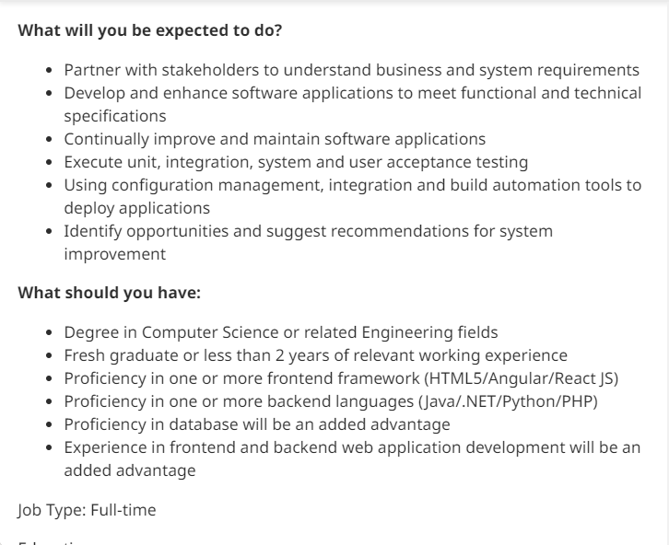

This is my Tailored CV for the job description I described above.
Oakar |  | No.666, yishun street 51, 03-499  +65 81922709  Rhythmic34u@gmail.com  https://twitter.com/xinxin693
  Address: | No.666, yishun street 51, 03-499
  Phone: | +65 81922709
  Email: | Rhythmic34u@gmail.com
  Website: | https://twitter.com/xinxin693
OBJECTIVE
A student who is currently studying in Bachelor of Computer Science from Coventry University which the course is supported by PSB academy. I have been interested in the software development field since I was 12 and have some websites I develop as a fun project on side. I am eager to learn new things from my experiences and from other people and colleagues too.

SKILLSET
Soft Skills  - Problem Solving  - Critical Thinking  - Teamwork  - Adaptability  - Being Patient  - Multi-lingual (Burmese, Chinese and English) | Professional Skills  - Programming (Python, JavaScript, PHP, MYSQL,)  - Web Development (REACT, HTML, CSS and Angular)  - A good understanding on algorithm and data structure  - Have a database experience.

EDUCATION

Bachelor of Science with Honors in Computing Science
March 2023 – Present

Coventry University, Singapore, PSB academy

Ncc lvl 5 Diploma In Computing
September 2019 –September 2020

MCC Institute, Yangon

Ncc lvl 4 Diploma in Computing
September 2018 – September 2019

MCC Institute, Yangon

Projects

Online shopping for Custom built PC, individual PC part and PC component
Create a full-stack website for customers to order items which is available in the store using PHP, and MYSQL database (html and CSS) included.
Recipe App using React which is JavaScript framework
Developed a recipe searching app using free API, use React: using useState and useEffect, html and css for design.

My Skillset

There is so many skillsets which I acquire through my year of experience in programming or through out my life. Each and one of them helps me to shape the present me and help the future me. Among the skillsets I learn, it can be divided into two groups. They are soft skills and hard skills.

Soft Skills
Soft skills are known for interpersonal skills which can be useful for mostly every aspect of jobs. These skills are hard to possess since there is no unique way or particular style to learn or acquire these types of skills. They are learnt through failure and mistakes from the experiences. The soft skills not only benefit our career but also our personal life.
Problem Solving
Problem solving is a process of Identifying the problem, determine the reasons or causes of the underlying problems, collect information for the possible solutions and make a best decision on a solution. This skill is required especially in jobs related to computer science. I encounter so many problems along the side of developing project and I develop this skill through projects, and I really increase my value.
Critical Thinking
Critical Thinking is the ability to evaluate the information and data and being aware of the assumption or biases including ourselves. It amplify your skills to gather knowledge, process information quickly and analysing data. As a student who want to dip into data science field, this is really an efficient and vital skill to possess.
Teamwork
There is no company with only one software developer since it is inefficient. Since we must work in groups, having a good teamwork skill is important. Having good teamwork skills already include good communication skill, decent conflict-management technique, listening skills, reliability from teammates and respect from the teammates. Having a good teamwork skill not only benefits our professional life but also our personal life.
Adaptability
Since I m currently residing in Singapore, where the cultures are diverse and so many nationalities, having an adaptability skill is a huge advantage. Adaptability not only means on people but also on technology which is increasing and developing in a rapid speed. 10 years ago, learning PHP and MYSQL is enough but nowadays companies are changing their technologies to more advanced and comfortable to use one example: MongoDB and Node.js. I don’t mean there is no company using PHP and MYSQL but I just want to highlight there is so many technologies are developing in an incredible speed, so we have to learn and adapt ourselves.
Being Patient
This is the skills I acquire since I was young by meditating and practising mindfulness. As a human, I experience being impatient and make a decision vigorously. Mostly they lead to a terrible ending. So, I learn from my mistakes, meditate more and learn more about patience. This skill is an essential skill in 21st century where everything is fast-paced, and we miss out the things which can be only be seen when we slow down.

Hard Skills
Hard skills are the abilities which enable us to solve job specific duties and responsibility. They are usually learned through courses, training, on the job or through side projects. They are mostly focused on particular tasks, tools or technology.

Web Development
I pick up web development as a hobby and think that it will be fun. I started learning html and CSS and step into JavaScript. I found myself really enjoying the design and stuff so I know that I am into front-end development. Although there are many front-end framework like Angular and Vue, I pick React as there are so many recommendations on reddit group and I search on job portal and saw React developer are in demand. I teach myself react by doing little projects on the side while attending high school.
Programming
I learn programming when starting with web development. I start with JavaScript, and I found out python. I fall in love with its simplicity and easy to read format. Python is also easy to operate and one of the most popular languages. It is also one of the main language for machine learning which is AI and data science which is the field that I want to commit into. For PHP and MYSQL, I learn in my college when doing a project for my assignment. Although they are a bit outdated, they are a bit interesting to learn.
Algorithm and Data Structure
An algorithm is a series of steps to solve a particular problem when a data structure is how the data can be stored or organized data. At first, I am not interested in how the algorithm and data structure work. So, my answers are correct but they have really bad time complexity and bad data structure. I learn algorithm and data structure and this is my one of my best decisions in my life. The more I learn, the more I get interested, how a solution can be made with less resources and less time complexity.

Career Planning for Next 5 Years
Everyone has their own plan or goals and I do too. Benjamin Franklin said “By failing to plan, you are preparing to fail. I always tell myself I want to become a data scientist but I don’t have plan for that. This is great opportunity to plan these things out.These are the things I plan myself or where I see myself in within 1 year, 3 years and 5 years.

Within 1 Year | Within 3 Years | Within 5 Years
Graduate with BSc (Hons) in Computing Science | Improve my professional skills through certificates and open projects to polish my skills | Create a AI start-up company which serve convenience to the customer worldwide by using the network that I have through 5 years
Develop a good portfolio and data science project which can solve a real-world problem | Work as a data scientist which can offer a lot to the world by making people life easier.
Improve on skills that I lack like leadership, academic writing skills | Develop side projects and learn new technologies that emerge at that time to stay in current and not to left behind
Attend Data science course, which focus on statistic and mathematic and how to apply them | Step into machine learning project as a data scientist which is leading the currently technology which will become the future, the AI | Teach Junior data scientist or programmer from my experience and making them shine on their own career
Get a job in a tech company where I can learn as many things as I can by the senior and manager and open the door for a massive ton of opportunities. | Accumulate experience through jobs and building a network.

Conclusion
This coursework really strength me what are my strength and what are my weakness and also how to apply the strength and how to fix my weakness. It also prepares me to write different style and type of CV for the future. Furthermore, it brings me back to my past the skills that I had and the experience. It prepares not only for the present but also for the future. By planning the career, it brings insights to what I have to learn and what I have to face. Writing this coursework open a lot of eyes and ideas for myself and chances for my job recruitments by teaching me how to write a good CV, what I am strong at and how to plan for my future.

References
Indeed Career Guide, 2021. Hard Skills Vs. Soft Skills: Definitions and Examples. [online] Available at: < https://sg.indeed.com/career-advice/career-development/hard-skills >[Accessed 7th April].
Smith, J., 2021. How to write a CV | Prospects.ac.uk. [online] Prospects.ac.uk. Available at: < https://www.prospects.ac.uk/careers-advice/cvs-and-cover-letters/how-to-write-a-cv > [Accessed 7th April].
Doyle, A., 2022. Tips for Adding an Attention Grabbing Title to Your Resume. [online] The Balance Careers. Available at: < https://www.thebalancecareers.com/how-to-write-a-resume-headline-2061036 > [Accessed 7th April].

